

Spring Term 2026 Menu
Weeks Commencing: 5th January, 2nd February & 9th March

Week 1 | Monday | Tuesday | Wednesday | Thursday | Friday
Main Option | Maccaroni Cheese & Garlic Bread  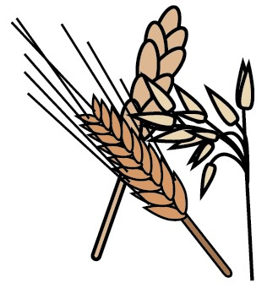 | Pepperoni Pizza with Skin On Fries | Butcher’s Sausage with Roast Potatoes,  Yorkshire Pudding & Gravy   | Barbecue Chicken  Thighs with Rice | Fish Fillet with Chips  & Ketchup  
Meat Free Option | Tomato Pasta & Garlic Bread | Cheese Pizza with Skin On Fries | Quorn Roast with  Roast Potatoes,  Yorkshire Pudding & Gravy | Barbecue Quorn Fillet with Rice | Vegetable Burger with Chips & Ketchup
Alternative Option | Ham or Cheese Baguette    or  Jacket Potato with a Choice of  Filling | Turkey or Cheese Roll  or  Jacket Potato with a Choice of  Filling | Tuna or Cheese Sandwich  or  Jacket Potato with a Choice of  Filling | Ham or Cheese Roll  or  Jacket Potato with a Choice of  Filling | Bagel with Choice of  Topping  or  Jacket Potato with a Choice of  Filling
Vegetables | Baked Beans or Salad | Salad | Broccoli | Sweetcorn | Peas
Dessert | Pudding of the Day  Salad Bar & Fresh Fruit or Yoghurt Available Daily
All meals are prepared fresh on the day using local fresh products when possible
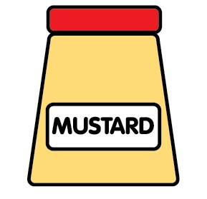


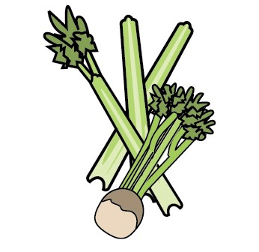
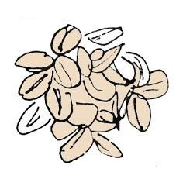

No nuts are present in any of our meals or in the preparation area, however some meals contain the following (a full list of allergens can be requested):

Celery Wheat Milk/Dairy Eggs Fish Sulphites Mustard Soya Barley Oats Sesame

